# Summary book

## Large scale

### Large Length scale => latitude variability

Global generated waves:

#### Tectonic features

* Leading edge

1. Narrow shelf steep coastal profile
2. Large waves
3. Rapid, short and straight streams
4. Coarse sediment supply from river to bays

* Trailing edge
* Amero-trailing edge

1. Wide shelf: limited wave action, large tides and amplitude, storm surge heights.
2. Large supply of sand and fines
3. Temperate climate
4. Broad coastal plains, delta and barriers.

* Afro-trailing edge

1. No high mountain ranges
2. Little river sediment supply
3. Tectonic stable
4. No extensive deltas

* Neo-trailing edge

1. Coasts are steep with beaches backed by sea cliffs

* Marginal sea coasts

1. Have greatest diversity of form.
2. Volcanic island arc.

#### Material distribution

* Sand

Lower middle latitude

* Mud

Humid temperature or tropical hot climate zones (mainly depend on river discharge)

* Rock and gravel

High latitude and high relief coasts.

* Coral

The most common in areas with high temperatures

#### Tides :

Generally occur at 65 degrees S and propagates northly.

* Generation:

attraction force by sun and moon. Differential pull.

* Compensation:

differential pull is balanced by water level gradient.

* Equilibrium theory:
* Assumptions:

1. No inertial
2. Earth is covered by uniform water depth.
3. Neglect friction and Coriolis force.

* Daily equal height

1. 2 HW and 2 LW a day with the same height (caused by differential pull only)
2. Spring-Neap: beating of M2 and S2 tide.

* Variability:
* Daily inequality

1. Origin: caused by declination (earth orbits around the sun)
2. Time variability: max. in June (23.5 deg), min. in Dec (-23.5 deg) and 0 deg in Spring and Autumn.
3. Spatial variability: latitude with monthly and annual cycle.

* Latitude variability

Generally, near the tropics, semi-diurnal tide configuration dominates while near the polar, diurnal tide dominates due to inclination.

Tide variation not only depends on latitudes but also some local features (bathymetry or geology), an example described is tidal basin, in some specific tidal basin near the tropics, only diurnal tides are observed because the frequency of the tide constituents mixes with basin’s own frequency so that cause the dominance of diurnal tidal property.

* Propagation of Tide
* Small amplitude tidal wave
* In absence of friction and amplification, tidal propagation celerity can be estimated as , otherwise, it is not applicable.

**Inertial force is balanced by water level gradient.**

**Progressive wave condition**

* Kelvin wave

Tidal wave is bounded by land mass.

1. Coriolis force is balanced by water level gradient. (Coriolis force acts on objects with mass-transport and in the non-inertial frame)
2. No friction.
3. Cross-shore: Geo-strophic (Coriolis is balanced by hydrostatic pressure)
4. Along-shore: progressive shallow water waves (inertial is balanced by hydrostatic pressure)

* Propagation features

1. Co-phase line: connect all places with HW (straight line)
2. Co-range line: connect all places with the same tidal range. (circle around amphidromic point)
3. Amphidromic point: 0 tidal range.

#### Wind waves:

* Generation

Wind is driven by pressure gradient. Specifically, from high pressure to low pressure (or to say from low temperature to high temperature)

* Variability
* Seasonality

We consider situations in NH only, the other way around in SH.

1. In summer, land temperature is much higher than ocean temperature, hence wind blows from ocean to continent.
2. In winter, land temperature is lower than ocean, hence wind blows from land to ocean.

* Spatial variability

From tropics to polar, wind-waves are categorized as swell and storm waves.

Swells are travelling along the great circle.

Storm wave features: west coast swell

1. Energetic wave condition 1. Located between 0 to 40 deg
2. 40 to 60 deg N and S 2. Year-round in SH
3. Year-round in SH 3. In winter in NH
4. Winter in NH 4. In tropics, stem from trade winds
5. Locally generated by westerlies 5. Long waves
6. Westerly to south-westerly. 6. Wave height 1-2 m

#### Comparison of waves and tides features

* Wave dominated features

1. Dynamic sandy coastal profile
2. Beach slope dependent of wave characteristic

* Tide dominated features

1. Tides smear beach morphology
2. Wide-low gradient and muddy tidal flats
3. Salt marshes, mangroves
4. Tidal ridges

### Large Time scale

#### Sea level rise

* Deglaciation of water

1. Change in the amount of water.
2. Change in expansion of water.
3. Change in the gravitational force distribution of earth.

* Subsidence of the earth surface

1. Glacio-isostasy: loading and unloading by ice
2. Hydro-isostasy: loading and unloading by ocean water

* Continental movement

Continents divergent or convergent.

#### Long term Sediment transport

* Self-organization
* Positive feedback

Curvature-induced secondary flow; large wave angle approaches a bump;

Escoffer’s curve before the first equilibrium point

In a tidal basin, increase channel volume will cause positive feedback, which deepen the channel in a long run.

Beach states from dissipative to reflective (rip current) (downstate takes weeks or months)

* Negative feedback

Small wave angle approaches a hump

Escoffer’s curve at equilibrium point

* External forcing

Extreme Storm wipes out all features of reflective beach. (upstate takes hours or days)

* Bar cycle

In cross-shore direction, under strong wave conditions, bar starts migrating offshore. Its size increases until the edge of upper shoreface and then vanishes at the end of lower shoreface.

#### Morphology changes

* Cross-shore profile retreats due to SLR

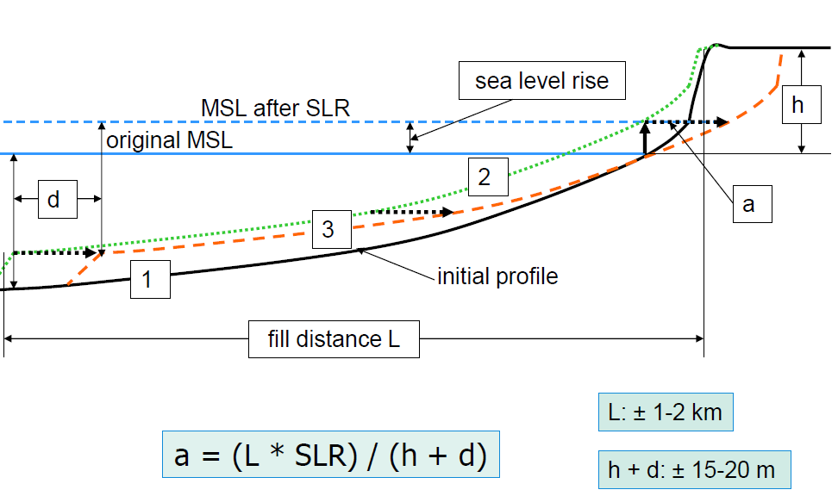

## Small scale

### Small Length scale

#### Locally generated waves

* Storm

1. most energetic wave environment

2. locally generated by westerlies and associated mid-latitude cyclones

3. located 40 and 60 deg N and S

4. Operates year-round in the Southern hemisphere and in winter in the Norther hemisphere

* Wind-driven currents
* No closed boundary

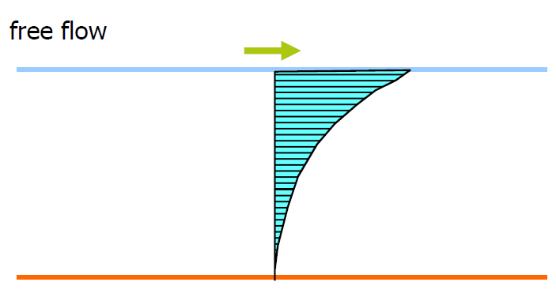

* Closed boundary

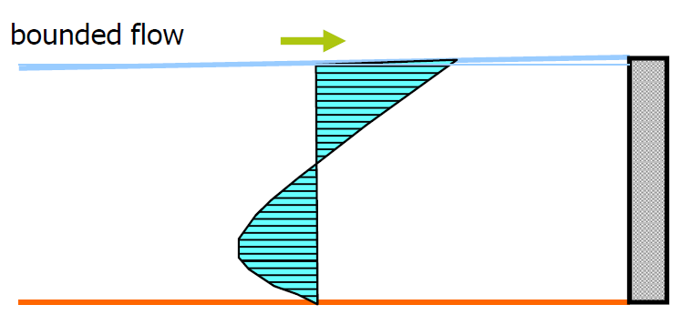

#### Waves influenced by local bathymetry

* Wave refraction
* Definition

Wave rays are prone to be perpendicular to the depth contour.

* Snell’s law

wave angle vs celerity is constant when approaching shoreline

* Wave diffraction
* Definition

Waves interact with structures and In the shadow zone, wave penetrates into it with reduced energy.

* Quantitively description

For regular wave, penetrated wave height reduces to 50 percent of original and 70 percent for irregular waves.

* Wave breaking

Note: only for wind-generated waves, tidal waves don’t break

* Definition

When wave’s orbital velocity exceeds celerity, wave starts breaking.

“White-capping” in the deep water, the origin of white-capping is steepness. When wave height is too large compared to wave length.

* Quantitively description

At breaking point, the maximum wave height is proportional to the water depth with a parameter . It varies with different breaking types such as plunger or spilling etc.

#### Tides influenced by local bathymetry

* Tidal basin
* Short basin

1. short basin length much smaller than a quarter of the tidal basin.

2. at the landward end and seaward end, purely standing wave property.

3. LWS occurs at LW and HWS occurs at HW (standing characteristic)

4. “pumping mode”. Waves in the basin almost like in the oceans

5. resonance happens when kLb = pi/2.

6. tidal prism is defined as tidal basin area times tidal range.

* Long basin

1. friction force should be taken into account.

2. velocity leads elevation 90 degrees when only consider friction force in tidal propagation (neglect inertial force)

3. phase difference should lie in the range of 0 to 90 degrees in reality.

### Small time scale

#### Storm events

* Cross-shore profile retreats

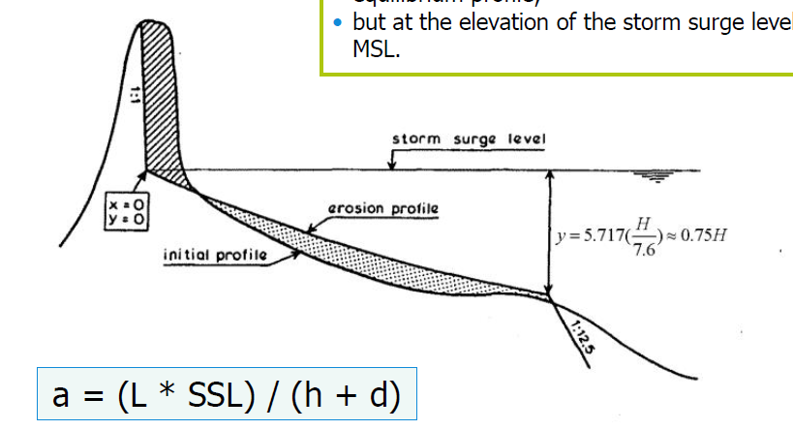

Where, L is the distance of where erosion take place. D: dune height above the MSL

* Protection

Hard structures: revetment, sea dike, seawall

#### Alongshore erosion

* Sediment transport rate gradient
* Protection

Hard structures: detached breakwater, groynes series, dams

## Morphodynamic changes

Key point: morphodynamic changes are due to sedimentation or erosion.

### Sediment transport driven forces

#### Wave

* Wave bottom shear stress stir up sediments

Shorter wave period, larger shear stress, which accounts for more stirred sediments.

* Wave transport sediments
* Cross-shore direction

1. wave asymmetry and skewness

Asymmetry: is caused by difference of celerity of crest and trough

Skewness: is caused by higher Stoke’s terms as in the shallow water.

Positively skewed wave will import sediment while negatively export for coarse sediment (quasi-steady)

2. undertow

Undertow is caused by wave breaking/mass flux balance, resulting in large return current (offshore directed)

1. LH streaming

A purely oscillatory flow, a non-zero wave-averaged horizontal flow (on shore directed) and is independent of time (P182). Mainly in the shoaling zone, small in the surf zone (because it is compensated by undertow).

* Along shore direction

Wave driven currents

Radiation stress Syx will give a net sediment transport alongshore.

#### Tides

* Tide driven currents(Alongshore)
* Tidal asymmetry and skewness

Skewness: is caused by overtides components (M4,M6 etc)

Asymmetry: is caused by falling period mismatch rising period (comparable to wave celerity diffenrence)

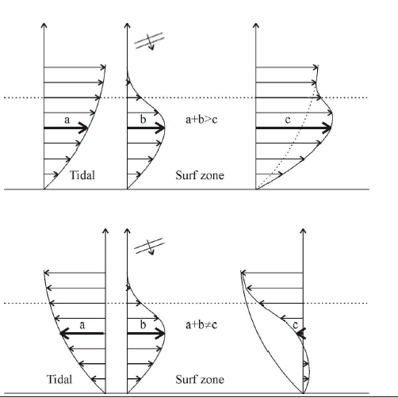

* Tide generated residual flow
* Stokes’ drift

A stokes’ drift in the direction of tidal propagation will occur if more than half of the flood tide coincides with water levels above the tidal cycle mean water level. If horizontal tide and vertical tide are 90 degrees out of phase, then there is no residual flux.

* Curvature induced

Under the centrifugal force and Coriolis force’s effect, water flows towards the center of the curvature.

* Bathymetry induced

Residual flow in deep channel is ebb direction while in shallow channel is flood-direction

* Tide transport sediment mechanism
* Flood dominant: sediment import

In a flood dominant condition, velocity magnitude at HW is larger at LW, which gives a sediment import for coarse sediments.

For fines, because HWS period is longer than LWS, which give enough space and time for fines to deposit.

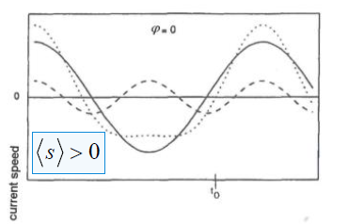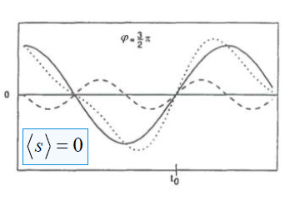

* Ebb dominant: sediment export

Follow the same story.

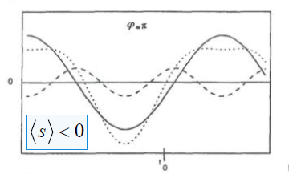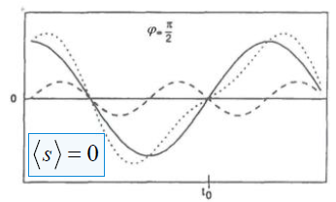

* Determination of dominance in tidal propagation

The basis of flood dominance is HW vs LW, when water depth at HW is larger than at LW, celerity at HW is higher than at LW, rising period is shorter than falling period, the magnitude of current is larger at HW=> coarse sediment import, at the same time, because of longer HWS (flat backface and steep frontface), which give enough time and space for fines to settle.

The same story for ebb-dominant situation.

* Flood dominance: small intertidal area, shallow channels, small flats (consequence). Deep channel, large flats will enhance ebb-dominant system. (hHW>hLW)
* Ebb dominance: large intertidal area, deep channels, large flats (consequence). On the contrary, shallow channel, small flats will enhance flood-dominant system. (hHW<hLW)

#### Wind driven currents

Alongshore, wind-induced current follows the same pattern of wave-induced

### Cross shore morphology

#### Sediment transport rate

* Governing equation:

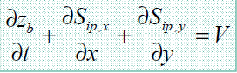

Limitations: 1. Only for 1D problem.

* Mainly Influence factor ---wave
* Sediment stirred up

When waves are breaking, sediment can be stirred up due to turbulence.

Shorter the wave period, larger the turbulence factor so that the short wave is more responsible for stirring up sediments and to cause bed sheet flow or suspended transport.

* Sediment transport

Sediment is transported by currents: LH streaming, undertow, long waves, short waves (in cross-shore direction)

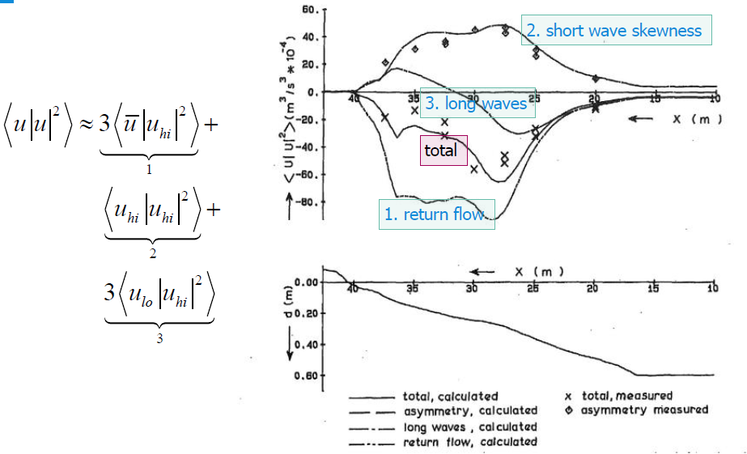

On-shore directed:

Free long waves (in the surf zone); short waves (shoaling to surf); LH streaming

Off-shore directed:

Bound-long waves (in the shoaling zone); undertow (surf zone); down-hill (gravity)

#### profile changes

* Sea level rise incurred shoreline retreat

As indicated above,

* Storm incurred shoreline retreat

Indicated above, the magnitude of shoreline retreat for Dutch coast is typically 100m per year

* Bar migration

Over years (large time scale), bars generally move offshore under energetic conditions and move a little back under mild wave conditions and skewed waves. It grows in size until a maximum is reached at the end of upper shoreface and then vanish with distance.

#### Beach states

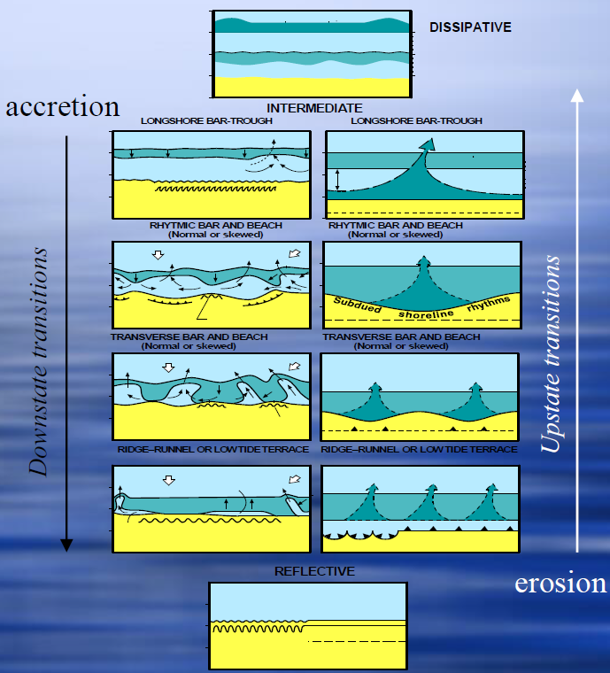

Time scale of upstate transition: episodic events

Time scale of downstate transition: weeks or month.

Dissipative beach has typical “winter” profile because of large energy and reflective beach has typical “summer” profile because of less dynamic condition. Transition from dissipative beach to reflective beach causes sedimentation because generally, summer is abundant in sediments and the other way around for reflective to dissipative because of external force (storm) erosion.

### Alongshore morphology

#### Sediment transport rate

* CERC formula

Limitations: 1. Hb is defined as the root mean square wave height.

2. only at breaking point, if in the deep water, S is only proportional to square of wave height.

3. only wind-waves are taken into account.

4. sediment properties are ignored. Basically, it compensates with slope but generally, sediment transport rate decreases when increasing slope because wave breaking parameter changes.

5. sediment transport rate is not actually maximum at incident angle 45 degrees because for larger angle, wave breaking take places at smaller water depth.

#### Coastline changes

* The driven force of coastline change is sediment transport gradient.
* Single line theory
* Control volume

At two cross-sections, if sediment transport rate at inlet and outlet doesn’t vary, we can draw a conclusion that, sediment inside this volume, no net loss and net gain.

* Structural erosion and accretion

The main effect of breakwater is to prevent erosion of shoreline for recreation.

* Shore normal breakwaters

Shore normal breakwaters will have typical accretion at the upstream side and erosion at the lee side.

From the orientation of shoreline, we could infer the wave angle. (perpendicular to the shoreline)

* Detached breakwaters

1. emerged breakwaters

Emerged breakwaters generate a shadow zone of wave, which causes accretion at the back of breakwater.

Tombolo: when the length of breakwater is twice the large as distance from shoreline, it forms a tombolo.

Salient: when the length of breakwater is less than twice of the distance from the shoreline, salient occurs.

2. submerged breakwaters

Submerged breakwater protect shoreline in the case of set-up gradient if a breakwater is well-designed. Rip current is generated offshore direction and take sediments out.

* Shoreline equilibrium

If we consider a bump (along shore) is influenced by wave generated currents,

1. under small wave angles (<45 deg): the bump will be wiped out after enough time and forms a equilibrium shoreline “negative feedback”

2. under large wave angles (>45 deg), ideally it will stretch into the outside of surf zone. This is called a “positive feedback”

## Tidal basin

**Key point: tidal prism**

#### ****Tidal prism****

* Definition

The volume of water entering or leaving the basin per half tidal cycle.

* Quantitve description

Tidal prism = tidal range * basin area

Limitations: 1. Limited tidal flats

2. tidal range is constant (short basin)

#### Ebb delta

* Ebb delta under wave conditions

Wave: to decrease outer ebb delta and increase flood delta because ebb delta is exposed to wave and wave’s effect is to wipe out it so that it transports sediment inside and when velocity decreases, sediment deposits inside.

* Ebb delta changes

Empirical relationship between ebb delta volume and tidal prism.

* Reclamation

Tidal prism reduces => the volume of ebb delta decreases => if the decreased volume cannot supply the loss volume of channel => erosion of downdrift of adjacent coastlines

* Closing the inlet

Closure of part of tidal basin => channel volume decreases => prism decreases => ebb delta volume decreases => if decreased volume cannot supply the loss of channel => erosion of downdrift of adjacent coastlines

#### Inlet

* Equilibrium theory

Stability of inlet cross-sectional area

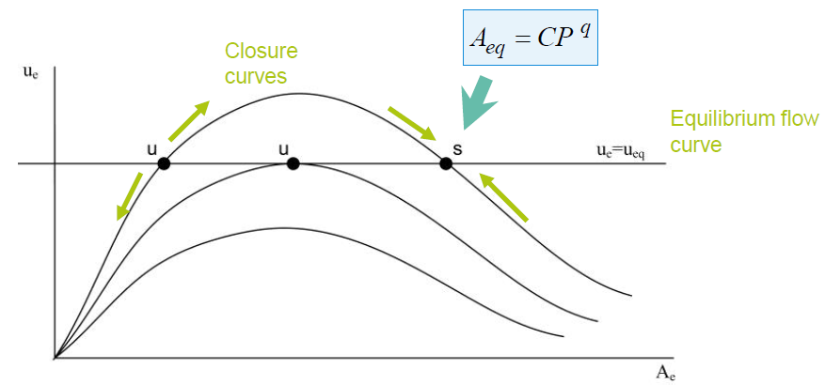

Equilibrium velocity is only dependent on diameter of sediments

* Equilibrium velocity

At the equilibrium point, if velocity increases, the area will decrease, which means that the smaller inlet area, but with increased velocity, the open mouth will be eroded until the equilibrium situation achieves.

When decreasing the prism, inlet cross-sectional area decreases, and velocity increases a little and then achieve equilibrium point. At the mean time, because of decreased area, the curve will shift downwards.

before the first intersection point, channel velocity increases for an increasing cross-section, but the channel is not choked off any longer, increasing area will cause the reduction of maximum current velocity.

#### Tidal Channel

* Property

1. Ebb-dominant channel behaves more like meandering river because of curvature induced secondary flow. (deep)

2. Flood-dominant channel is shallower than ebb-channel

* Relationship between tidal prisms

#### Flood Delta

* Empirical relationship

When basin area decreases => tidal prism decreases => channel volume decreases => flood dominant causes sediment import => flat area increases.

## Waves perspective

### Wave energy

#### Conservation of wave energy

Limitations: 1. Steady state, alongshore uniform

2. friction is not taken into account.

3. only applicable before wave breaking

#### Wave energy to analyze

* Energetic approach to analyze sediment transport

In the bed load flow, energy is used to migrate sediment.

In the suspended flow, wave energy is to keep them in suspension.

* Energy convergence at the headline and divergence in the embayed place.

Sediment transport gradient between two headlines are 0

* Energy balance between two wave rays approaching the shoreline

#### Energy distribution in the cross-shore direction

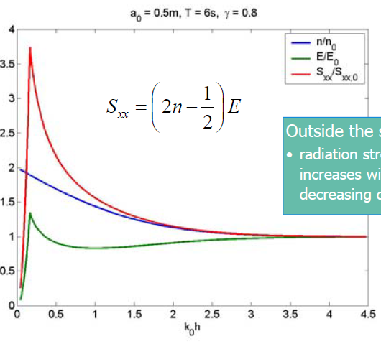

### Wave radiation forces

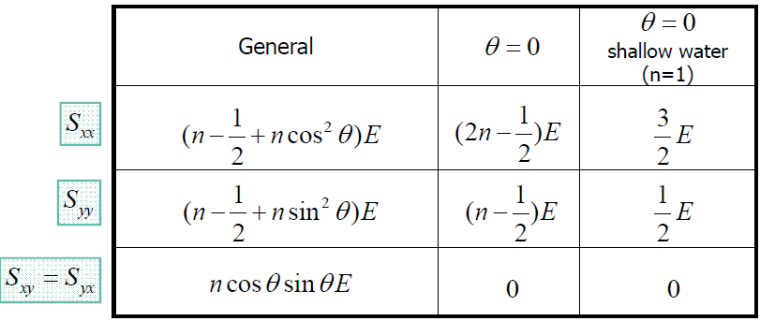

Alongshore uniform coast, Syy=0

#### Cross-shore direction

**For alongshore uniform coast:**

|  |  |  |
| --- | --- | --- |
|  | Set-down | Set-up |
| elevation |  |  |

#### Alongshore direction

Alongshore, wave force is balanced by shear stress if there is no bound in wave propagation direction.

Alongshore current:

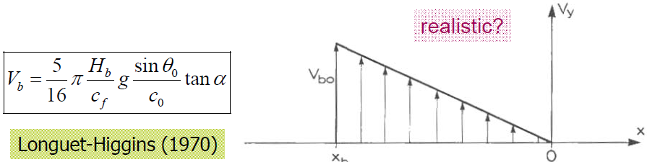

### Wave propagation pattern

Consider a tidal basin is whether standing wave or progressive wave:

1. reflection. If incoming wave is reflected all without damping, this is purely standing wave pattern.

2. friction. If friction dominant, wave is more likely to be a progressive wave, or to say, reflection wave is all damped out.

3. in a short basin, we can assume little friction so that we expect a standing wave. (pumping mode)

4. at the landward end of any basin (only if the wave can propagate into that point), always standing wave pattern.

#### Standing wave pattern

* Standing wave properties

1. No friction

2. Reflection

3. velocity leads elevation -pi/2

4. only friction (no inertial)

* Standing wave occurrence

1. In short basin, it occurs at the seaward and landward end. (frictions are negligible)

2. In any basin, landward end.

3. Seiches

4. tidal waves under the condition of only friction playing an role (balanced by water level gradient) in propagation but when it flows into a basin, shallow water eqn is used and velocity leads elevation pi/4.

#### Progressive pattern

* Progressive wave pattern

1. No friction

2. Inertial dominant

3. velocity and elevation no phase difference

* Progressive wave occurrence

1. Kelvin wave (when travelling along the boundary)

2. Normal tidal wave and regular waves, wind waves